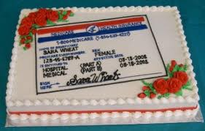Are You Turning 65?!

**You are invited to The SHIP Monthly Medicare Birthday Bash!**

**With so many options and almost daily post cards arriving at your house, the choice can be confusing and a little overwhelming.**

**Before you turn 65 come to our monthly Medicare Birthday Bash for help:**

**WHERE: GM&O BUILDING**

**110 Beauregard St**

**Mobile, AL 36603**

**WHEN: FIRST TUESDAY of Every Month**

**TIME: 9:00am until 12:00pm**

**WHAT TO BRING: Proof of Income; Medicare card;**

**List of Medications; Picture ID**

**There will be an educational seminar on Medicare and other related programs, let us help answer your questions about Medicare and choosing a plan. The SHIP program offers FREE, unbiased information as your health care advocate.**

**For more information contact us:**

**251-433-6541 or 1-800-243-5463 or email:** [**jroberson@sarpc.org**](mailto:jroberson@sarpc.org)

